大學入學考試中心

110年試辦考試（適用於108課綱）

英文考科

|  |
| --- |
| －作答注意事項－  考試時間：100分鐘  作答方式：  ˙選擇題用 2B 鉛筆在「答題卷」上作答；更正時，應以橡皮擦擦拭，切勿使用修正液（帶）。  ˙除題目另有規定外，非選擇題用筆尖較粗之黑色墨水的筆在「答題卷」上作答；更正時，可以使用修正液（帶）。  ˙考生須依上述規定劃記或作答，若未依規定而導致答案難以辨識或評閱時，恐將影響成績並損及權益。  ˙答題卷每人一張，不得要求增補。  選擇題計分方式：  ˙單選題：每題有個選項，其中只有一個是正確或最適當的選項。各題答對者，得該題的分數；答錯、未作答或劃記多於一個選項者，該題以零分計算。  ˙多選題：每題有個選項，其中至少有一個是正確的選項。各題之選項獨立判定，所有選項均答對者，得該題全部的分數；答錯個選項者，得該題的分數；但得分低於零分或所有選項均未作答者，該題以零分計算。 |

第壹部分、選擇題（占62分）

一、詞彙題（占10分）

說明︰第1題至第10題，每題1分。

1. News reporters need to base their stories on trusted sources in order to avoid ______ the public.

(A) misplacing (B) misleading (C) misjudging (D) mistreating

1. Under the doctor’s care, my grandmother has been making ______ progress since her knee operation.

(A) steady (B) routine (C) mobile (D) conscious

1. Amy asked her brother to turn down the ______ of the stereo so that she could hear her friend clearly on the phone.

(A) intensity (B) volume (C) frequency (D) operation

1. Famous for his great achievements as an artist and scientist, Leonardo da Vinci is one of the ______ figures of the Renaissance.

(A) universal (B) artificial (C) dominant (D) conventional

1. To stop the spread of the illness, anyone who fails to wear a mask in the hospital can be ______ service and even fined.

(A) charged (B) directed (C) refused (D) pardoned

1. Before the invention of farm machinery, farmers had to ______ from dawn to dusk in the fields all year round.

(A) drill (B) harvest (C) shift (D) labor

1. The boy insisted that there was a monster in his room, but it was actually an ______ created by the moonlight.

(A) array (B) entry (C) outlook (D) illusion

1. Instead of remaining ______ at home, many retired people take part in social activities and do volunteer work.

(A) idle (B) stiff (C) vacant (D) sensible

1. At many busy international airports, taxis are ______ available at all hours to provide transportation services to incoming travelers.

(A) merely (B) strictly (C) readily (D) variously

1. Long years of wars have forced many civilians to leave their homeland and live in ______ as refugees in other countries.

(A) awe (B) exile (C) fraction (D) boredom

二、綜合測驗（占10分）

說明︰第11題至第20題，每題1分。

第11至15題為題組

Denmark consistently scores high in global happiness rankings, and Danish people have some cool words for ways to be happy. The word recently voted most popular among Danes is *pyt*, a term that describes the nation’s philosophy toward 11 .

*Pyt* doesn’t have an exact English translation. It is usually used as a 12 to a daily mistake or small frustration, corresponding roughly to the English sayings, “Don’t worry about it,” or “Well, things happen.” At its core, the word is about accepting and resetting—a reminder to step back and refocus rather than overreact. *Pyt* doesn’t point blame at either yourself or another person; 13 , it helps you learn that not everything can be perfect. But this does not mean that *pyt* applies to everything. It should not be used when you ought to take responsibility; 14 should it be taken as an excuse for inaction.

Today, the word is even manifested into a literal “*pyt* button” in Danish classrooms for schoolchildren to press when they are upset about something insignificant. Some adults have also started using the button at home. Basically, *pyt* encourages people of all ages to 15 minor frustrations and move on with their lives.

11. (A) health (B) stress (C) culture (D) friendship

12. (A) hand gesture (B) body movement (C) verbal response (D) facial expression

13. (A) therefore (B) likewise (C) however (D) instead

14. (A) so (B) nor (C) only (D) nearly

15. (A) let go of (B) look up to (C) go in for (D) come up with

第16至20題為題組

Goose bumps are one of those fight-or-flight reactions of the sympathetic nervous system. When you experience cold or fear, a nerve reaction is sent to the muscles, which then contract involuntarily. This muscle contraction causes your body hair to stand erect. The skin with standing body hair 16 a goose’s skin after its feathers have been plucked—hence the name goose bumps.

But 17 is this helpful to us as a response to fear or cold? Back in the days when our ancestors may have had a lot more body hair, this might have helped to keep them warm or scare an oncoming predator. These days, however, goose bumps are 18 to human beings. Goose bumps, or the reflex that causes them, also occur in many other mammals. Many mammals fluff up their fur when 19 , to look bigger and thus more dangerous. For example, when a porcupine encounters a predator, its long sharp pointed hairs will stand up as a means of 20 . In animals with a thick hair coat, the rising of hair traps more air between the hairs, providing another layer of insulation to keep them warm.

16. (A) imitates (B) explains (C) develops (D) resembles

17. (A) how (B) where (C) what (D) whether

18. (A) even more ridiculous (B) no longer useful

(C) still quite convenient (D) more than important

19. (A) threaten (B) threatening (C) threatened (D) to threaten

20. (A) blocking the smell (B) attracting mates

(C) showing friendliness (D) scaring the enemy

三、文意選填（占10分）

說明：第21題至第30題，每題1分。

第21至30題為題組

In the traditional religions of Africa, life does not end with death. After death, humans continue to  
 21 as spirits. Some African groups believe these spirits dwell underground in a world much like that of the living—but upside down. Other groups believe the sky is the permanent 22 place of the dead. For instance, the Bushmen of southern Africa believe that the spirits of the dead go up to the sky and become stars.

Among the spirits, the ancestors 23 a special category of their own. As ancestors, they have some extra powers. To become an ancestor is the best that one can 24 after death. However, not everyone who dies will turn into an ancestor. For one to become an ancestor, there are 25 to be fulfilled while the person is alive—living an upright life and fulfilling all social and religious duties, for example.

Many African groups believe that the spirits of ancestors remain near their living descendants as  
 26 of the family and their traditions. They help in times of trouble as long as their descendants perform proper rituals and pay them 27 respect. But they punish people if certain ceremonies have not been performed properly or if there are some 28 of community laws.

Ancestor worship also plays a very 29 role in the mythologies of some African peoples. For example, the people of Buganda in present-day Uganda say that their first ancestor was Kintu, who came from the land of the gods and married Nambe, daughter of the king of heaven. Another example is the Dinkas of Sudan, who believe they are descended from Garang and Abuk, the first man and woman created by God as tiny clay figures in a pot. For these Africans, the honored dead have become not only objects of worship but also 30 of tales and legends.

(A) due (B) subjects (C) guardians (D) conditions (E) live on

(F) resting (G) hope for (H) significant (I) violations (J) comprise

四、篇章結構（占8分）

說明︰第31題至第34題，每題2分。

第31至34題為題組

Generous billionaires are not hard to come by, but it is definitely a challenge to find a billionaire who spends all his fortune on charity just to end up broke. 31

Feeney, who grew up in a poor neighborhood of New Jersey, is a genius at finding business opportunities. Since childhood, he would take any job to make a few cents for his family—jobs like distributing umbrellas in summer and selling Christmas cards in winter. In his college years at Cornell University, he sold home-made sandwiches to other students and is still remembered there as the Sandwich Man. Then, in the 1960s, Feeney established airport retailer Duty Free Shoppers (DFS), which helped him reach his billionaire status by the 1980s. 32 He lived modestly, and often pondered what to do with all the money he made.

Influenced by his upbringing, Feeney decided to give away all his money to those in need in his lifetime. In 1984, the then 53-year-old Feeney signed over everything—his DFS shares and the various businesses and properties he had acquired worldwide—to Atlantic Philanthropies, a charity foundation he established. In the following decades, Feeney donated through the organization more than $8 billion anonymously, to charities, universities, human rights campaigns, and foundations worldwide. 33

Pioneering the idea of “Giving while Living,” Feeney is a role model for many famous billionaires today, including Bill Gates and Warren Buffet. 34 In September 2020, Feeney’s go-for-broke mission was completed, and he now lives happily with his wife on a pension in a modest apartment in San Francisco.

(A) However, Feeney never felt at ease with the lifestyle of the wealthy.

(B) He encourages people to donate at least half their fortunes before death.

(C) This is exactly what happened to “former” American billionaire Charles Feeney.

(D) Such incredible secret generosity won him the title “James Bond of Philanthropy” from *Forbes* magazine.

五、閱讀測驗（占24分）

說明︰第35題至第46題，每題2分。

第35至38題為題組

Islands are different from a continent or mainland. The size and isolation of islands have a profound effect on island ecosystems and their inhabitants.

Scientists who specialize in species evolution have found that, among mammal species that settle on islands, big species tend to shrink while small ones are apt to enlarge. This phenomenon, discovered by J. Bristol Foster in 1964, has been called Foster’s rule, or the island effect. For instance, rodents (such as rats and squirrels) living on islands tend toward gigantism, while big mammals (like deer and elephants) are more likely to become dwarfed. Although there are a number of exceptions to this pattern, the trend generally holds true for both fossil species and living island mammals.

Foster’s rule shows that body size regulates everything. In a mainland environment, being large is often a safer and adaptive form of avoiding predators. On an island, with few natural predators and less competition, being really big is no longer an advantage; in fact, it can be a hindrance since a huge animal will need a lot more food in order to survive and reproduce.

A new fossil study of island-dwelling proboscideans (i.e. prehistoric hairy elephants) further shows that the physical attributes and ecological structure of an island may affect the degree of shrinking in big mammals. On relatively balanced and species-rich islands, competition with other species often result in a relatively less dwarfed body size. In contrast, on smaller islands where food sources are limited and competitors lacking, members of **this group** become smallersurprisingly quickly.On one of the Channel Islands 15 miles off the coast of France, the red deer dwarfed to one-sixth the size of deer on continental Europe in a mere 6,000 years after the island became isolated.

35. What is the second paragraph mainly about?

(A) The reasons why mammals change and evolve through time.

(B) A comparison of gigantism and dwarfism on different islands.

(C) The different patterns of evolution for big and small island mammals.

(D) The similarity between the evolution of fossil species and that of living species.

36. According to the passage, what is a problem big mammals might face on an island?

(A) There may not be enough food.

(B) It is harder to find shelter on small islands.

(C) It may be difficult to move around on small islands.

(D) They become less competitive due to lack of natural enemies.

37. What does“**this group**” in the fourth paragraph refer to?

(A) Fossil species. (B) Natural predators.

(C) Big mammals. (D) Limited competitors.

38. How does the author conclude the last paragraph?

(A) With a prediction. (B) With a summary.

(C) With a suggestion. (D) With an illustration.

第39至42題為題組

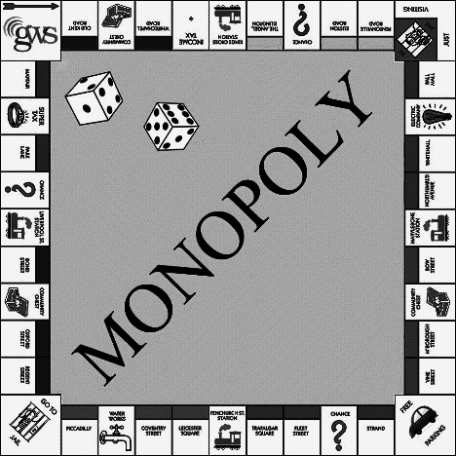Monopoly is a very popular board game around the world today, but little is known about its American inventor, Elizabeth Magie, and the philosophy behind her invention.

Born in 1866, Magie was a rebel against the norms and politics of her times. Inspired by Henry George who believed that all men should have an equal right to use the land as they have to breathe air, she challenged the capitalist system of property ownership—in the form of a board game. In 1904, she patented her Landlord’s Game, which consisted of a circuit of streets and landmarks for sale.

Magie’s game contained two sets of rules: The Prosperity rules and the Monopolist rules. The Prosperity rules stated that every player should gain each time someone acquired a new property. The game was won (by all!) when the player starting with the least money doubled his or her fortune. Under Monopolist rules, on the other hand, each player advanced by acquiring properties and collecting rent from all who landed there later. Whoever managed to bankrupt the other players won the game. The purpose of the dual sets of rules, said Magie, was for players to understand how these different approaches to property can lead to different social outcomes: “all win” or “win all.”

The game soon became a hit on college campuses and among Quaker communities, and some people modified the game board. An unemployed player named Charles Darrow sold this modified version to the manufacturer Parker Brothers as his own. However, when the game’s true origin came to light, Parker Brothers bought the patent from Magie for only $500. They then re-launched the game as Monopoly, including only the rules leading to the triumph of one over all. Darrow was publicized as the inventor who had become a millionaire from selling the game. Thus **a rags-to-riches** **myth** was created, ironically exemplifying Monopoly’s implicit values: Chase wealth and crush your opponents if you want to come out on top.

39. What is this passage mainly about?

(A) The creation and modification of a board game.

(B) A fight between patent owners of a popular game.

(C) A socio-economic victory behind a landlord game.

(D) The person who became a millionaire from a fun game.

40. What was the main purpose of Magie’s Prosperity rules?

(A) To emphasize the value of the capitalist system.

(B) To introduce different approaches to obtaining new land.

(C) To advocate that all should be rewarded when one acquires wealth.

(D) To challenge George’s idea that men should have an equal right to the land.

41. What does “**a** **rags-to-riches myth**” refer to in the last paragraph?

(A) A modified version of Monopoly.

(B) Darrow’s success after selling the game.

(C) Parker Brothers’ purchase of Magie’s patent.

(D) The popularity of the game on college campuses.

42. Which of the following would best describe Magie’s feelings toward today’s version of her game?

(A) Excited. (B) Relieved. (C) Embarrassed. (D) Displeased.

第43至46題為題組

For decades, India’s time zone has been a hotly debated issue. Back in 1884 when time zones were officially established, two time zones were used—Bombay Time and Calcutta Time. Indian Standard Time (IST) was introduced in 1906, but Calcutta Time and Bombay Time continued to be maintained after India’s independence in 1947, until 1948 and 1955 respectively. The current single time zone, though a legacy of British rule, is often viewed as a symbol of unity. Yet, not everyone thinks itis a good idea.

India stretches 3,000 km from east to west, spanning roughly 30 degrees longitude. This corresponds to a two-hour difference in mean solar time, based on the position of the sun in the sky. Thus, the sun rises nearly two hours earlier in the east than in India’s far west. In Northeastern states, sunrise can be as early as 4 a.m. in summer and sunset by 4 p.m. in winter, much earlier than the official working hours. This results in great loss of daylight hours and more consumption of electricity, and often reduced productivity.

Meanwhile, recent studies point out that the current system leads to a serious problem in education for some students. Nationwide, the school day starts at roughly the same time; thus, children go to bed later and have reduced sleep in west India, where the sun sets later. Such sunset-induced sleep deprivation is more **pronounced** among the poor, mostly due to their noisy environment and lack of sleep-inducing facilities like window shades or indoor beds. On average, an hour’s delay in sunset time reduces children’s sleep by 30 minutes, and an hour’s delay in annual average sunset time reduces education by about 0.8 years. As a result, children living in locations with later sunsets are less likely to complete primary and middle school education.

Despite various requests and proposals for multiple time zones, the government is keen to retain the current system. Reasons provided include prevention of confusion and safety issues regarding railway and flight operations.

43. Which of the following illustrates the Indian time zone system since 1955?

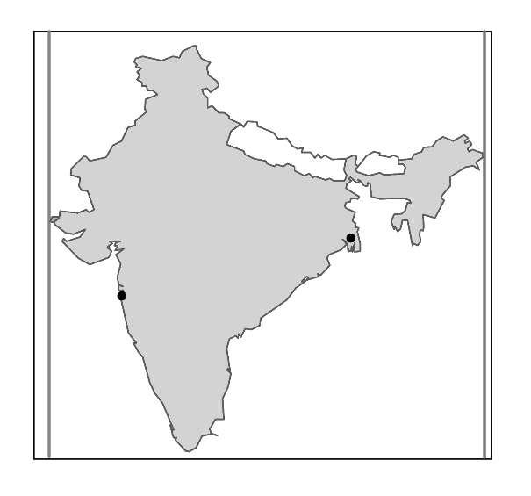

**7 a.m.**

Calcutta

Bombay

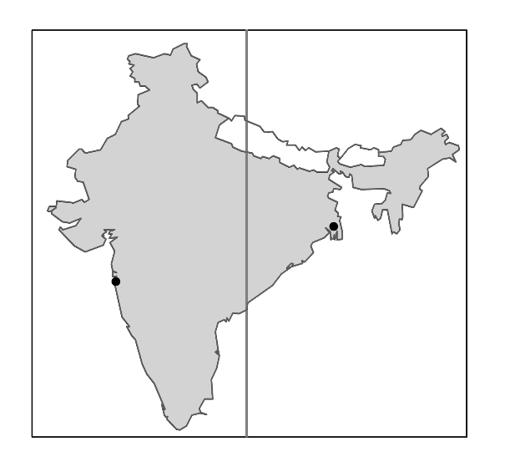

**7 a.m.**

**8 a.m.**

Calcutta

Bombay

(A) (B)

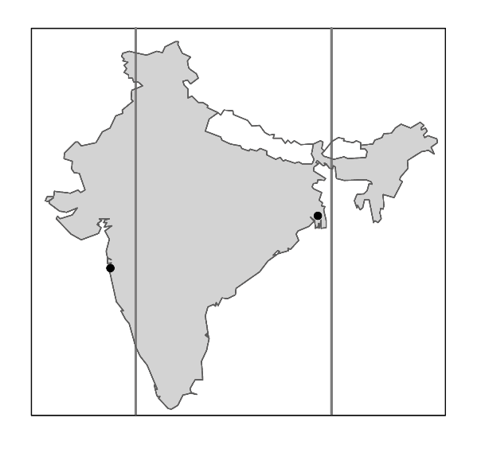

**7 a.m.**

**7:30 a.m.**

**8 a.m.**

Calcutta

Bombay



**7 a.m.**

**8 a.m.**

**9 a.m.**

Calcutta

Bombay

(C) (D)

44. Which of the following is closest in meaning to the word “**pronounced**” in the third paragraph?

(A) Serious. (B) Flexible. (C) Distant. (D) Noisy.

45. According to the passage, which of the following is a supporting argument for multiple time zones?

(A) The number of traffic accidents can be reduced.

(B) Children may have better-quality sleep and education.

(C) India may have more energy resources to generate electricity.

(D) The country may rid itself of the impact of British colonization.

46. According to the passage, when is most likely the sunset hour in December in the city of Varanasi shown on the map?

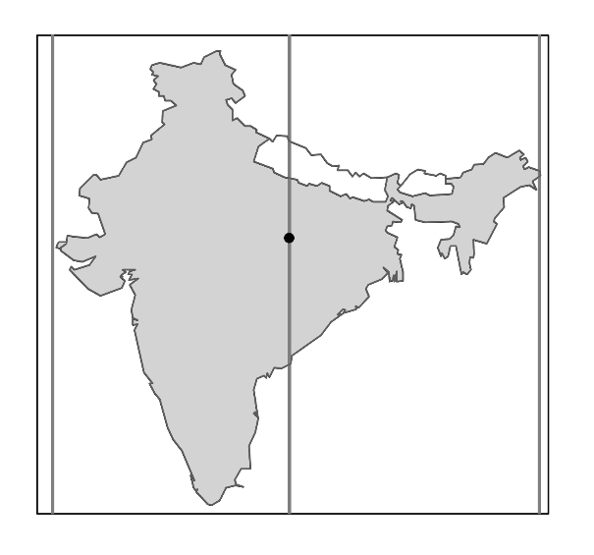

97ﾟE

68ﾟE

83ﾟE

Varanasi

(A) 7 p.m. (B) 6 p.m. (C) 5 p.m. (D) 4 p.m.

第貳部分、混合題（占10分）

說明︰本部分共有 1 題組，每一子題配分標於題末。限在標示題號作答區內作答。選擇題使用 2B 鉛筆作答，更正時，應以橡皮擦擦拭，切勿使用修正液（帶）。非選擇題請由左而右橫式書寫。

第47至50題為題組

Richard I was the king of England from 1189 to 1199. He was known as “Richard the Lionheart” because he was a brave warrior and was said to be afraid of nothing. After ascending the throne, Richard led an army to join the Third Crusade to recover Christian holy sites from the Muslims. He fought side by side with the Duke of Austria, Leopold V, and together they conquered the powerful fortress of Acre in 1191. However, when Richard reached the top of the castle to claim victory, he displayed only his own banner and not that of Duke Leopold, who was absent at the time. This was an insult too much for the duke to bear, so he placed a price on Richard’s head.

Richard was aware of the danger awaiting him on his way back to England after the war. However, he had no other choice but to cross through Austria, a land controlled by **his unfriendly former ally**. Richard traveled in disguise but was recognized and caught before reaching Vienna. Duke Leopold held Richard at Dürnstein, a castle on the bank of the Danube River. After a few months, Richard was handed over to the German Emperor Heinrich VI. A ransom of 35 tons of silver was demanded by the duke and the emperor to release Richard. That was a huge amount for England to pay.

In 1194, the ransom was paid and Richard was finally released, though the effort it took to raise the money affected people throughout England. The silver was split between the German Emperor and the Austrian Duke. The Austrians used it to improve the city walls of Vienna and some small towns in the east. It was also used to establish the Austrian mint and make silver coins. Until the 1960s, small amounts of the silver stemming from the ransom could still be found in Austrian 10 Schilling coins.

47. 請從文章第一段中選出一個單詞（word）填入下列句子的空格，並視語法需要作適當的字形變化，使句子語意完整、語法正確，且符合第一段文意。（填空，2分）

After the conquest of Acre in 1191, the Duke of Austria was very upset because he felt he had been greatly 47 .

48. Who does “**his unfriendly former ally**” in the second paragraph refer to?（簡答，2分）

49. Which word in the passage means “a place where coins, medals, or tokens are made”?（簡答，2分）

50. What happened to Richard I, Heinrich VI, and Leopold V in the story? From (A) to (F) below, choose the statements that are true according to the passage.（多選題，4分）

1. Richard I got his revenge at the end.
2. Heinrich VI received part of the ransom.
3. Richard I lost his throne after the incident.
4. Leopold V claimed victory alone after the battle at Acre.
5. Leopold V rebuilt towns and city walls with some ransom money.
6. Heinrich VI captured Richard I and handed him over to Leopold V.

第參部分、非選擇題（占28分）

說明：本部分共有二大題，請依各題指示作答，答案必須寫在「答題卷」標示題號之作答區內，作答時不必抄題。

一、中譯英（占8分）

說明：1.請將以下中文句子譯成正確、通順、達意的英文，並將答案寫在「答題卷」上。

　　　2.請依序作答，並標明子題號。每題4分，共8分。

1. 很多人害怕公開演講，常在上台之前發抖、覺得頭昏。

2. 只要我們對自己有信心，並持續練習，就可以克服怯場的問題。

二、英文作文（占20分）

說明︰1.依提示在「答題卷」上寫一篇英文作文。

2.文長至少120個單詞（words）。

提示︰你認為下面兩張圖片中呈現的是什麼景象？你對這些景象有什麼感想？請根據圖片內容，寫一篇英文作文，文分兩段。第一段描述兩張圖片的內容，包括其中的人、事、物以及發生的事情；第二段討論導致這個現象可能的原因，並說明你認為未來可以採取什麼具體的因應措施，以避免類似景象再度發生。

