d*" #b f*1 f/1 #b

#a

='d/" (~./",C)

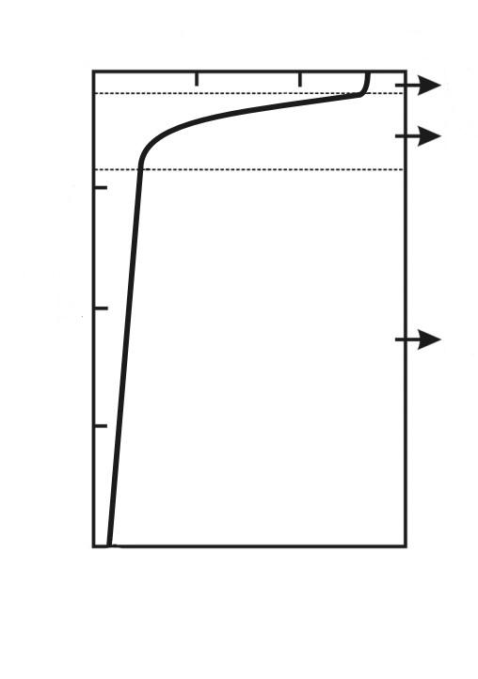
iu'd/" (km)
k)`
*`
oy`
#3
#2
#1
#10
#0
#20
#30
#4

d*" #aa f*1 f/1 #f
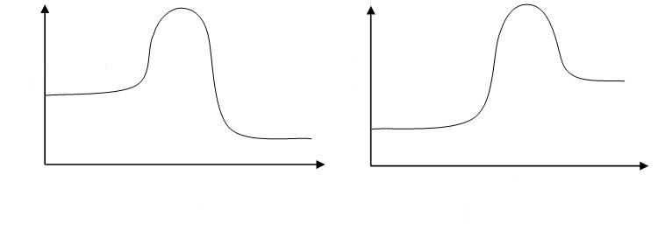
#b
qv`y"k3"bz1
nz1c."
,N2 (g) + #3,H2 (g)
#2,N,H3 (g)

d*" #aa f*1 f/1 #g

#c

qv`y"k3"bz1
nz1c."
,N2 (g) + #2,O2 (g)
#2,N,O2 (g)

d*" #13--#14 f*1h/` f/1 #h
#d

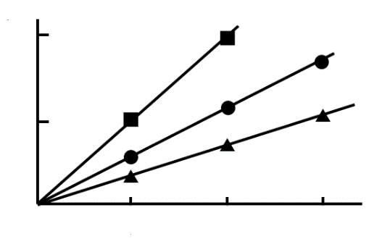
k)`
t1e}'f*`k*'{r%1iz'o
oy`
.,D,T (~./",C)
#0
*`
#0
#2
#4
#2
#4
#6

d*" #ah f*1 f/1 #i
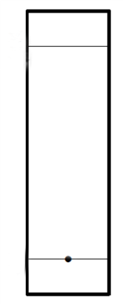
#e
,X
,Y
,Z

d*" #bf f*1 f/1 #ab
#f
,I

