#a
d*" #dj--#dc f*1h/` f/1 #f3 f/1c*"i3'my1


r91|`
m?`nv1|`
l!"|`,~1a/"m?1h/1|`k*1j*1f>'|`t1
r91|` + m?`nv1|`
d*" #dj--#dc f*1h/` f/1 #f3 #df--#ee e$"

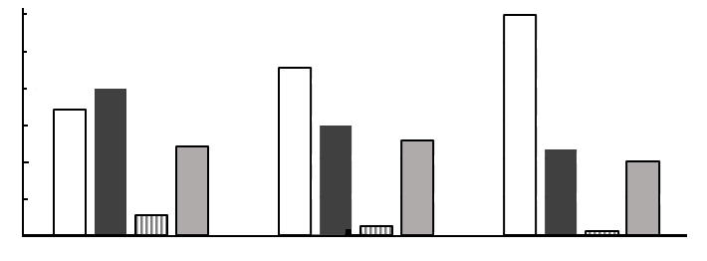

o/"f&1nt1cy1i:"dw"hw"k)'c*`h$"bx1i3'
d!a|`t1 7#bjac nt1d{"b>17
#df--#ee e$"
#0`0
#10`0
#20`0
#30`0
#40`0
#50`0
#60`0
#38.1`0
#32.6`0
#B
#5.2`0
#23.2`0

d*" #dj--#dc f*1h/` f/1 #f3 #cf--#de e$"

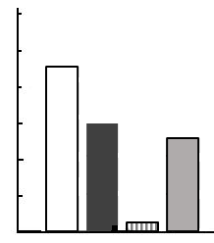
#cf--#de e$"
#C
o/"f&1nt1cy1i:"dw"hw"k)'c*`h$"bx1i3'
d!a|`t1 7#bjac nt1d{"b>17
#0`0
#10`0
#20`0
#30`0
#40`0
#50`0
#60`0
#24.7`0
#28.6`0
#2.5`0
#43.6`0
d*" #dj--#dc f*1h/` f/1 #f3 #be--#ce e$"

#57.3`0
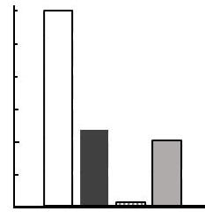
#be--#ce e$"
#D
o/"f&1nt1cy1i:"dw"hw"k)'c*`h$"bx1i3'
d!a|`t1 7#bjac nt1d{"b>17
#0`0
#10`0
#20`0
#30`0
#40`0
#50`0
#60`0
#19.1`0
#22.3`0
#1.0`0

d*" #df f*1 f/1 #g
#E
k)`
k&'bx`dw"
c%1k&'a/"aw1dw"
*`
oy`
dy'

