d*" #a f*1

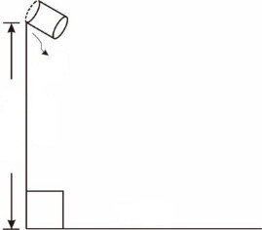
#a
j.1mt"
d*"mt"
#3 k&'b:`
#60~.*

d*" #e f*1
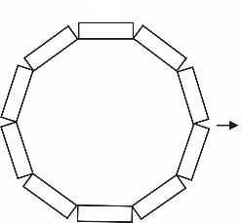
#b
#36~.*
#1

d*" #h f*1

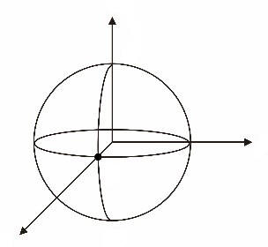
#c
,B
,S
,A
z
x
y
d*" #i f*1

#d
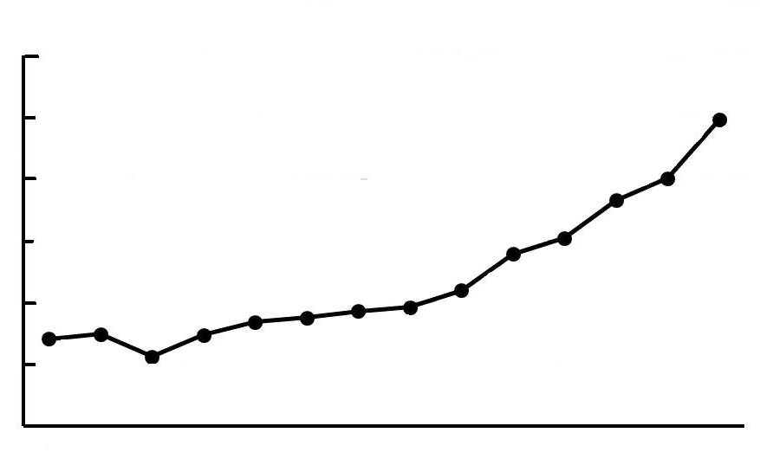
}"gu1
#bjje
#bjjg
#bjja
e*'~1nt1
#bjjc
#bjji
#bjaa
#bjac
k317"cw1fw1}'d!ac|`l!"gu1i/"a!1et"f/1
#0
#200
#400
#600
#1200
#1000
#800

