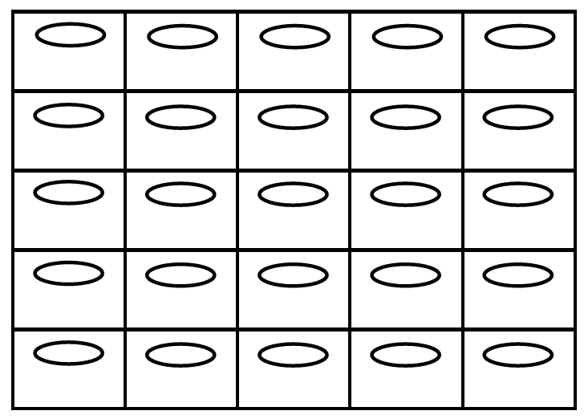
(1, 5)
(2, 4)
(1, 3)
(1, 2)
(1, 1)
(2, 5)
(1, 4)
(2, 3)
(2, 2)
(2, 1)
(3, 5)
(3, 4)
(5, 2)
(3, 2)
(4, 5)
(4, 4)
(4, 2)
(4, 1)
(5, 3)
(3, 3)
(5, 1)
(3, 1)
(4, 3)

(5, 5)
(5, 4)

#a
d*" #ag f*1

